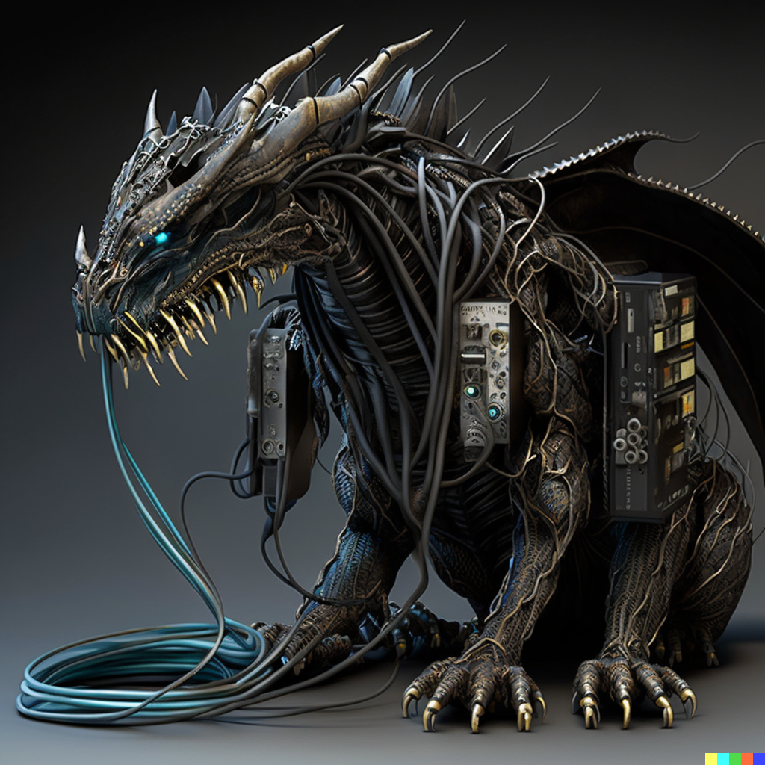

**End of the Universe**

**Genres**  
  
  
  
Action RPG